**Study and Analysis of Data Transfer with the help of LASER Beam**

Submitted in the fulfilment of

**KVPY**

by

**Gursimran singh**

**Thapar University, Patiala**

under the guidance of

Prof. Shalabh Gupta



Department of Electrical Engineering

Indian Institute of Technology, Bombay

Mumbai

ACKNOWLEDGEMENT

I would like to express my sincere thanks to KVPY cell for inviting me for this summer camp.   
At the end of this program, a student gets an excellent exposure into research field.  
  
I would like to thank Mr. Amit Shinde for his support and help throughout the duration of my stay.

It would be honour to thank Prof. Shalabh Gupta for accepting to mentor me and for his valuable views and ideas on this project.

I wish to thank my friends and KVPY invitees for their support and never letting me feel that I am away from home.

I want to thank my family for extending support all the way, and uncompromised support for such a unique experience of a lifetime.

Thank you everyone.

Laser Audio Transmitter

**Introduction**

This project is a proof-of-concept device that transmits an audio signal using a laser beam, while removing the need for the user to align the beam themselves.  
  
For our project, we created a mono-axial transmitter/receiver setup that converts an analog audio signal, via a standard 3.5mm jack, and transmits it via a laser to a receiver, which converts the signal back into audio. The receiver can be rotated within its horizontal plane, and uses a servo motor controlled by a microcontroller to automatically align it with the receiver. The end result is a wireless audio signal that cannot be “overheard” by other devices.

**Project Details**

Light is already becoming a popular means of communication, thanks to fibre optics, which can guide optical data much like a wire transmits current. It might seem impractical, then, to use lasers without a guiding medium to transmit information. However, in contexts where a physical connection is impossible or unfeasible, and the need for a focused beam arises, it would seem logical to use laser light. In particular, “free space” laser communication has useful to friendly ears, and ground-to-air links are important. We decided to create a simple and inexpensive proof-of-concept to demonstrate the advantages of this seemingly impractical scheme.

The circuit allows the transmission of an audio signal through the laser beam in the following way: the laser is provided via some external dc 4.5.volt source placed in series with the windings on a small low impedance transformer, the other side of the transformer is fed an audio signal at a level strong enough to drive a speaker , such as that from a radio or portable recording device , and, when the radio is fed through the transformer , it induces a small current flow and change in the impedance at the other side of the transformer where the laser is connected , thus creating direct modulation of the laser due to its fluctuating power source

LASER BEAM SENDER

Basically the small fluctuation in the laser power supply induced by the audio source into the transformer cause the laser beam to carry the information contained in the original audio source, the key component besides the laser pointer is the transformer. The perfect transformer for this project will be the one that was actually doing a similar job in the device that u will remove it from, changing or coupling an audio signal to some other device. Telephones, answering machines, older tape recorders are all good source of low impedance transformer for this project.

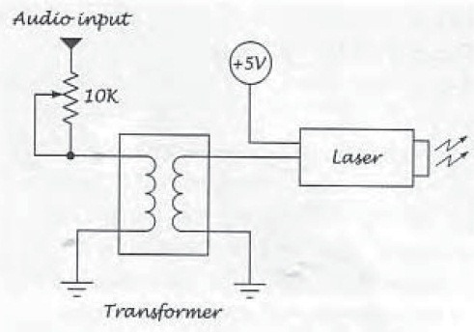

The laser beam transmitter

The transformer will have no less than four wires connected to it, and would have as many as six or more. We will be using four of them, to wires per side, measure the two wires or pins on each side of the transformer with an ohmmeter and make note of the impedance. if there are more than two wires on a side , measure across the two outer most wires to get a reading . If there is no reading , try random pairs until u get the lowest reading .

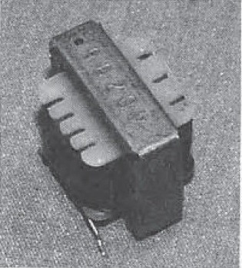

The laser side of the transformer is the circuit that connects the laser pointer in series with its power supply through the transformer’s winding as shown in figure.

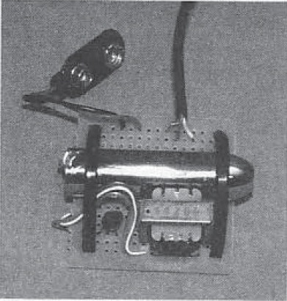

LASER BEAM RECEIVER

The circuit must operate in reverse to the laser beam transmitter, turning the modulated laser light back into an audio signal, which will be fed to an amplifier. The key to this circuit is the NPN phototransistor, a device that uses a light source to switch on the collector and emitter junction, and this is the reason why there are only two leads on the device. When any amount of light strikes the light sensitive area of the device, it causes a certain level of conductivity between the emitter and collector, thus creating n analog amplifier



The laser beam receiver schematic

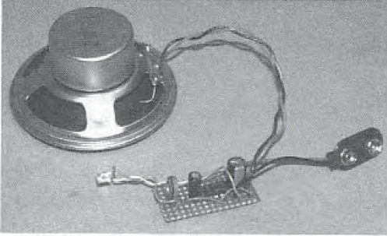

**Logical Structure**

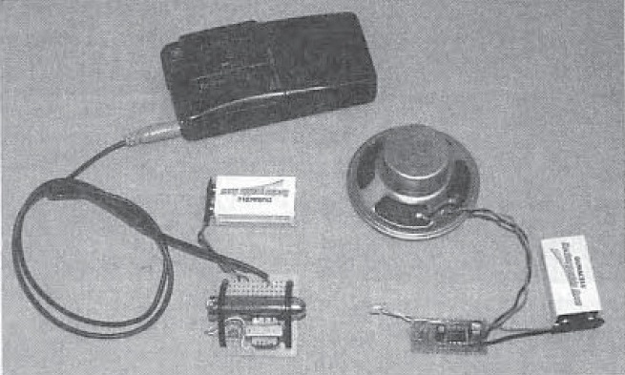

Short range testing

Our project is divided into two distinct sections: audio transmission via hardware, and alignment control via software. The former can be accomplished once the latter has succeeded, making the two tasks mutually dependent for overall functionality. The alignment is accomplished using a servo motor to rotate the transmitter until it aligns with the receiver. This is done by detecting the light emitted from the receiver’s laser using a phototransistor. The transmitter scans over its free range until it finds the receiver, at which point the transmitting laser is turned on and the audio signal is picked up by an array of photodiodes. The details of this process are explored below.

**Safety and Standards**

Since we are using lasers, the effects of exposure need to be considered. The lasers we used were purchased commercially, and comply with class IIIA power and safety specifications, as designated by the ANSI Z136.1 consensus. In the US, ANSI and OHSA standards specify the parameters under which lasers can be safely operated. For a class IIIA laser, the beams are generally not hazardous without the use of focusing equipment, though direct exposure to the eye should be avoided. With this in mind, we operated the device in a plane that lacked reflective objects and was well below eye level. Additionally, the transmitting laser is turned off when the exact direction of the laser is not known (i.e. when the transmitter is scanning the area). The receiver’s laser is limited to be just bright enough to be detected by the transmitter, but not at the peak amplitude.  
  
**Hardware/Software Trade-offs**

The audio signal sent by the transmitter is provided externally rather than via the microcontroller, since external devices represent more flexibility and mobility in the information that can be sent. Having the audio synthesized by the Mega644 would require some form of external memory and a method of flashing from an external source anyways, so we decided to cut out the middleman.  
The audio signal is sent via an analog transmission instead of decoding it into a digital signal. Optical transmission is usually done using with digital signals, requiring hardware for decoding at the receiver end. By transmitting the analog audio signal through laser amplitude modulation, we cut down on the transmitter and receiver hardware by eliminating the need for encoding and decoding processors.

Hardware

**Transmitter**

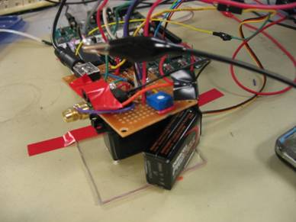  
Figure 1: Transmitter circuit, ready for operation.  
  
The transmitter is broken down into three circuits. The first circuit, which is similar to the receiver end, is the laser audio transmission circuit. This transmitter works by modulating the amplitude of the laser based on the amplitude of the audio signal that we are trying to transmit.

The audio, which is fed to the circuit through a standard 3.5mm audio jack, is sent to an adder circuit. The adder, shown below, consists of two inputs and a negative feedback resistor that will be summed together. The two connections to the non-inverting input of the op-amp are the audio signal and a DC bias signal that is generally kept at around 3V. This voltage can be modified by adjusting a potentiometer.    
  
The signal to the inverting input of the op-amp is half that of the output, which is obtained by using a voltage divider of two equal resistors. This feedback allows the op-amp to follow the amplitude of the non-inverting input as it attempts to equate the voltages at the two inputs.  
  
The output of the op-amp is sent directly to the laser. The amplitude of the laser is proportional to the voltage that is applied to it. The amplitude linearly follows the voltage up to roughly 4V, at which point the response is more exponential. We are taking advantage of the linear region of the response to send a mostly unmodified audio signal to the receiver for playback.  
  
The laser needs to be turned off while the transmitter is scanning for the receiver, mainly for safety and power reasons. To achieve this, the 9V supply to the op-amp is controlled by an NPN transistor, which can act as a switch controlled by the microcontroller.   
  
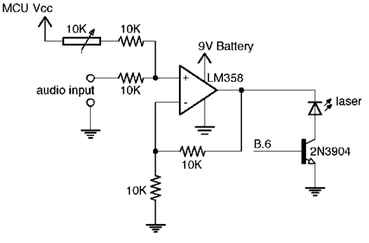  
 Figure 2: Main transmitter circuit. Modulates laser amplitude based on audio input.  
  
The second circuit in the transmitter is based on a phototransistor that responds to red light. When VCE of the transistor is set to 5 volts, the current flowing through the transistor is proportional to the amount of red light that is incident upon the detector. The current flows through the 10K resistor, resulting in a measurable voltage that is proportional to the incident light. This voltage is fed to the analog-to-digital converter of the microcontroller, and determines whether the receiver and transmitter are properly aligned and ready for transmission.  
  
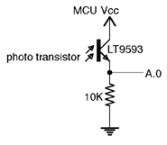  
Figure 3: Transmitter photo detector used for alignment purposes.

The last piece of the transmitter is the motor controlling circuit. We are using a servo motor to control the direction of the transmission. The motor is opto-isolated from the rest of circuit, and particularly, the microcontroller. This means that the motor is powered by a different power supply, and has no direct connections with any terminal of the microcontroller.   
  
The servo motor is controlled by a pulse, whose length corresponds with the desired position of the motor. Servos can achieve absolute positioning, while other types of motors can only be positioned relative to the current state. The precisely timed pulse is sent through a 330W resistor to the input of the isolator. The output of the isolator is simply the same pulse with a 5 volt amplitude, which is then sent to the motor for positioning.   
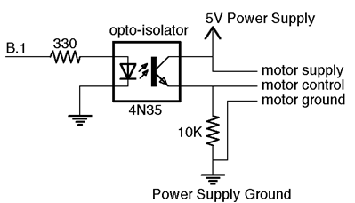  
Figure 4: Motor opto-isolator circuit. Pulse output goes to motor for angle control.

Receiver

The receiver circuit somewhat resembles the transmitter circuit. Rather than a single phototransistor, however, it instead uses three photodiodes, which have much larger sensitive areas compared to the transistor. Since the response of the diodes directly affects the audio quality, a more complex circuit is called for. The diodes themselves are placed between the two terminals of an op-amp, whose output voltage is determined by the current that flows through the diodes. Using an op-amp instead of biasing the diodes allows us to utilize a near-ideal short-circuit current. With three diodes in parallel, we effectively triple the area upon which we can receive a signal. After amplifying the signal with a second op-amp, the result is then fed directly to an audio jack, where the signal can be heard using any compatible device.  
  
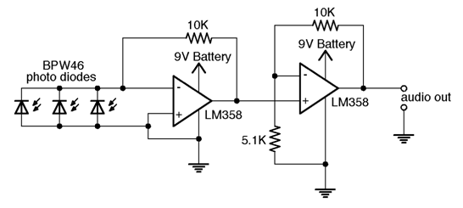  
Figure 5: Receiver main circuit. Reads detector voltage and amplifies before sending to audio jack.  
  
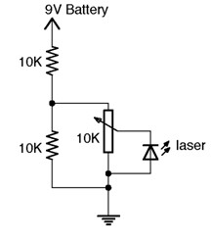  
Figure 6 (left): Receiver laser circuit. Used for alignment purposes.  
  
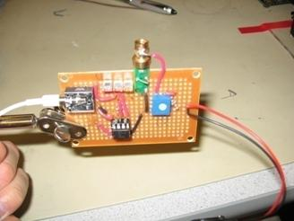  
Figure 7 (right): Receiver circuit, ready to operate.

Software

The software is designed to be completely interrupt-driven. Timing is based around the ability to control an output pin with a precise PWM output, allowing us to accurately control the motor for scanning purposes. The interrupt service routine is called once every five microseconds. Upon each interrupt, the program updates its timing counters, reads the output of the analog-to-digital converter when necessary, and performs state updates for receiver tracking purposes. 

**The State Machine**

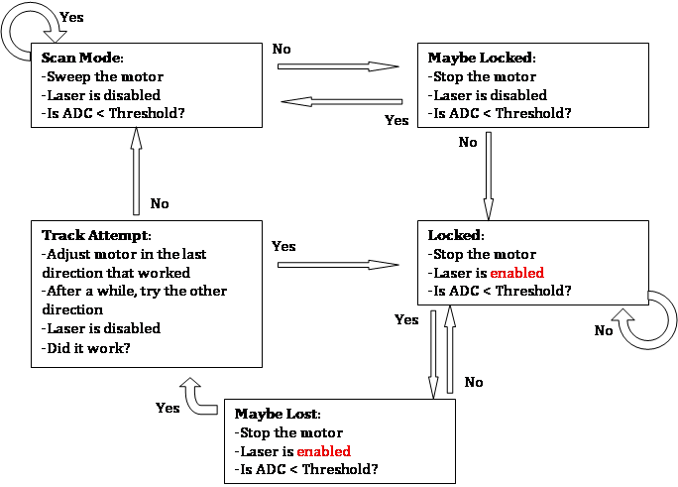  
Figure 8: Software state machine, used for transmitter scanning.

We use a simple machine to control the actions of the transmitter. The diagram above outlines its behaviour

**Hardware Control**

Through our timing control our hardware is relatively simple to manipulate. The servo motor we used uses the duration of a pulse to determine its angular position. To control this position, we set a pin high, and turn it off when a variable amount of time has elapsed. Since the execution of other instructions can have a noticeable effect on the true pulse width, this toggling is handled purely by the timer compare interrupt.  
  
Enabling or disabling the laser is as simple as toggling a separate pin.  
  
  
  
**Attempted Designs**

We attempted to implement a handful of designs that didn’t work out in the end. Hardware in particular went through a lot.  
  
Initially we thought (naively) that a servo motor did not need to be opto-isolated. Our motor disagreed, and vibrated erratically.  
  
The receiver went through multiple photoreceptive devices. We were going to use a solar cell, but saw that the response of a photodiode was good enough, so we used one of those instead. When we saw that the sensitive area of the phototransistor made alignment using two of them next to impossible, we switched to an array of larger photodiodes.  
  
The power supply for the motor was originally another 9V battery, but we quickly found that the current it supplied was insufficient.  
  
Lastly, to pour salt on our wounds, our custom Mega644 proto-board mysteriously died once everything else had been completed, taking our microcontroller with it (or vice versa?). We decided to switch to an STK 500 as our control source, lacking the time or resources to make another proto-board.  
  
The transmitter’s laser control also went through several iterations before we landed on the final design. Specifically, the circuit designed to the laser on or off during the scan stage was modified. Originally, the DC bias input to the adder would be controlled by a potentiometer, which could be adjusted to zero when during scanning. However this method was not automatic. We then tried to control the op-amp supply voltage with an output pin of the microcontroller, but found that supplying 5 volts caused circuit to be unable to output greater than 3 volts at the output, whereas we needed an audio signal centred at roughly 3.5 volts. We also originally had a BJT that controlled a battery’s 9 volt connection to the op-amp supply, but found that if the transistor’s base voltage was kept at 5 volts, then the supply could not exceed 5 volts. We finally implemented the design described above and kept it as our final design.

Hardware Performance

**Audio**

When dealing with audio transmission, an important consideration is how well a range of frequencies is preserved in the output. Generally, the audible frequencies range from 20 to 20,000 Hz. To that end, we ran tests comparing input waveforms with the signals generated by the receiver for various frequencies within this range. An example oscilloscope trace is shown (barely) below.

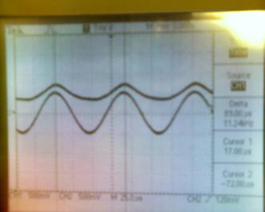  
Figure 9: Oscilloscope trace of input vs. output (smaller signal). At audible frequency the correlation is high.  
  
Through our tests we found that the output frequency remains the same as the input, and that the shape of the signal (a sinusoid in our tests) was preserved within the audible range. At around 50 kHz the response time of the photodiode is no longer negligible and some distortion can be seen, as shown below.  
  
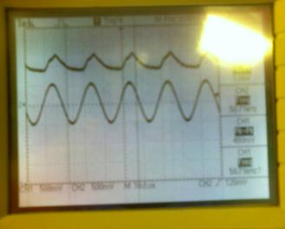  
Figure 10: As the frequency climbs beyond the audible range, the circuit has trouble responding.  
  
The relative attenuation of different frequencies was also measured. The graph below shows how the relative amplitude depends on frequency.  
  
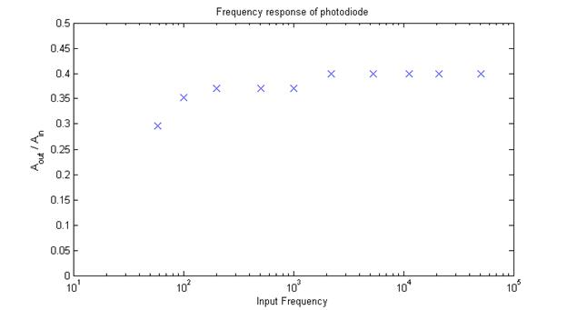  
Figure 11: Receiver’s frequency response.  
  
While high frequency signals are transmitted uniformly, the response drops off at the low end. The system acts on a whole as a high-pass filter with a critical frequency near 100Hz. Therefore, audio with heavy bass components will suffer the most while other components will be largely unaffected.

**Motor and Alignment**

The small servo motor performs admirably under the load of the transmitter circuit, operating smoothly and consistently. However, the physical connections to the power supply for the motor and the stk 500 causes the base to slide on all but the roughest of surfaces without adhesives. Once anchored, this is a non-issue.  
  
The transmitter and receiver align moderately well. Care must be taken in placing the receiver, as its laser must point towards the center of rotation of the transmitter. Even with this satisfied, there remains a degree (no pun intended) of flexibility in the angle of the transmitter while in the “LOCK” state, which means that the transmitter beam can miss the photodiodes of the receiver as the distance between the two increases. When we switched to the array of three photodiodes, the frequency of this misalignment occurring decreased noticeably. Partial misses can also occur when the beam is between two diodes or slightly off one of them. The result is that different volumes are required in the source to prevent distortion. The impact on safety is negligible, however, given that the normal precautions associated with lasers are kept in mind.

**Interference**

We found that the only interference came from audio contamination due to nearby electronics. The levels of noise did not seem greater than what you might hear in cheap audio products, however.

**Software Performance**

On its own, the software controlling the tracking logic works without any flaws. The timing of the motor signal executes consistently, as evidenced by the operation of the motor itself. The device is capable of tracking a moving beam fairly well, though it can easily lose a beam that displaces consistently faster than approximately 5 degrees per second. If it guesses incorrectly which direction the beam went, the beam can be lost more easily. Acquiring a lock works consistently however, and we did not witness any occurrences of false positives in our testing.

**Usability**

In general, the device can be successfully operated by anyone with two hands, functioning eyesight, and a surplus of patience. The amount of constant voltage supplied to both lasers can be manually adjusted via trimpots to compensate for various visibility conditions, and the audio signals can be supplied and received with anything using a standard 3.5mm stereo jack (though the output is mono).

Conclusions

**Expectations, Retrospect, and Possible Improvements**  
  
Our final product nearly met our initial expectations. We didn’t expect the audio quality to be as good as it was given the relative ease of designing the circuits, but the unreliable nature of the alignment was something we hadn’t anticipated, and didn’t have a solution readily available for. The software took less grief and misery than we thought, and generally worked without much cajoling.  
  
With these points in mind, there are a few things we would have done differently. The software could be expanded to allow for the transmission of a digital I/O stream, using the RS232 capabilities of the Mega644 and more symmetry in the transmitter/receiver modules. This would allow us to tap more of the potential of the microcontrollers and broaden the usefulness of the device.  
  
As for hardware, we found that considering every device as if the operating conditions were ideal cost us time and money that could have otherwise been more productive. Not considering the area of the phototransistors, for example, was an avoidable oversight. Additionally, with more time and an expanded budget we could deal with the alignment issue and build on it: with more investment in optical hardware the lasers could be secured with more precision, and their beams could be broadened and re-collimated. Additionally, with a more costly gimbal setup another dimension could be added to the range of the device, and with infrared imaging we could make the alignment process more accurate.  
  
The last-minute failure of the proto-board came as a heavy blow to us late in the game. Being more prepared for the worst might have saved us some grief if we’d sampled more than one Mega644 and made more than one proto-board.  
  
**Standards**

Our lasers are always operated at power levels equal to or less than that of their original design. To reduce the chances of stray beams, the transmitter is disabled until it acquires a lock. Additionally, the lasers themselves scatter a fair amount of red light from their cavities, making their operation obvious. Given these factors, and the low power of the lasers themselves, we believe we have followed the laser safety standards.  
  
**Intellectual Property Considerations**

All of our code is original, and the designs for our circuits were not taken from an outside source. Since the idea for laser signal transmission is already a large part of many applications, we are confident that our device does not infringe upon the intellectual property rights of other parties. Bearing that in mind, we do not feel our device merits a patent claim. The results of the project, while somewhat novel, are not exactly unheard of and do not merit publication, save as a DIY.  
  
**Ethics**

Referring to the IEEE Code of Ethics, we believe we have acted responsible as electrical engineers to the extent that our project allows. By following strict precautions in using our lasers, we have avoided safety risks to ourselves and others. Since our work was independent of outside parties and purely in the interest of fun and learning, we avoided conflicts of interest and bribery, as well as slander or intellectual dishonesty. Lastly, we hope that our device is able to demonstrate to others the capabilities and limitations of optical communication.

Sender circuit and code

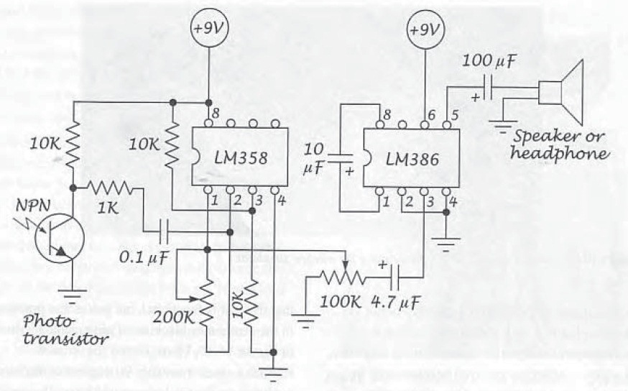

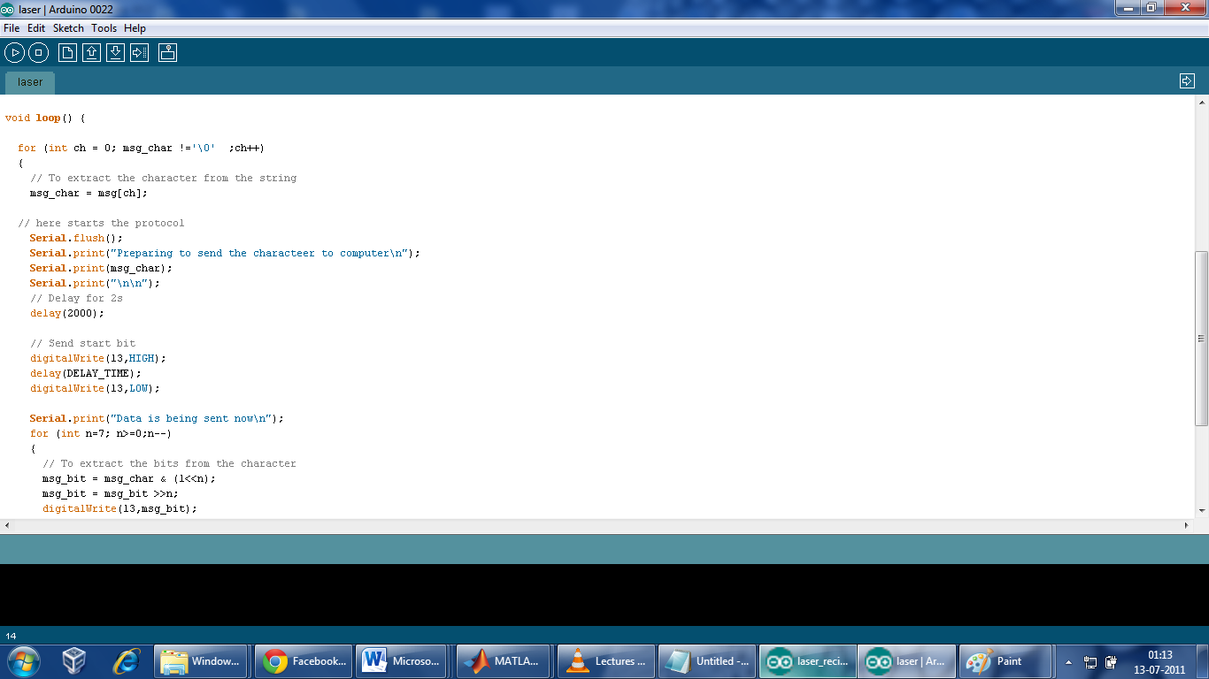

TRANSFER OF DIGITAL DATA WITH THE HELP OF LASER BEAM

INTRODUCTION

The transmission capacity of communication systems has evolved tremendously over the past 150 years, bringing borders, people and places closer together. Enabled by the technologies already developed, the transfer speed in a point-to-point connection can be almost as high as it is liked. Point-to-point connections are used as building blocks of larger networks and the sufficient connection band-width is determined within the network.

The first remarkable development in long distance communication was the invention of optical telegraph in 1791. Since then, the desire for topical information among people has been fulfilled with the help of inventions like electrical telegraph, telephone, radio and television. In all of these communication methods, the information from sender to receiver is transported over a certain transmission media, usually air or cable and today even optical fiber.

Optical communication networks are an essential part of the world wide telecommunication infrastructure. The number of users of present and future telecommunication services like internet, web browsing and tele-education will increase dramatically. As a consequence there is an imminent demand for broadband and high capacity communication systems. A promising solution is the concept of all-optical networks. Major research efforts in areas such as photonic integration and semi technology, among others, are currently directed toward the development of key components that will enable the construction of all-optical networks .

An optical communication channel is a pathway over which information can be conveyed. It may be designed by optical fiber that connects communicating devices, or by a LASER (Light Amplification by Stimulated Emission Radiation) or LED (Light Emitting Diode) that has no obvious physical presence.

Optical wireless technology often referred to as “free space optics” (FSO) is the clear line of sight technology. It enables optical communications at the speed of light without requiring fiber optic cable or seeing spectrum licenses. While fiber optic communication has gained acceptance in the telecommunications industry, free space optical communication is still relatively new. These state-of-the art technologies motivated to do research in optical communication area and this research work would be helped as a part to anyone who may be so interested in that field.

Code

/*

Made by Archit Gupta

modified Blink

Turns on an LED on for one second, then off for one second, repeatedly.

This example code is in the public domain.

*/

#define PULSE_TIME 100

#define DELAY_TIME 100

char msg[] = "simar";

int flag_startcomm=1;

char msg_bit = 'a';

char msg_char ='a';

void setup() {

// initialize the digital pin as an output.

// Pin 13 has an LED connected on most Arduino boards:

Serial.begin(9600);

pinMode(13, OUTPUT);

}

void loop() {

for (int ch = 0; msg_char !='\0' ;ch++)

{

// To extract the character from the string

msg_char = msg[ch];

// here starts the protocol

Serial.flush();

Serial.print("Preparing to send the character to computer\n");

Serial.print(msg_char);

Serial.print("\n\n");

// Delay for 2s

delay(2000);

// Send start bit

digitalWrite(13,HIGH);

delay(DELAY_TIME);

digitalWrite(13,LOW);

Serial.print("Data is being sent now\n");

for (int n=7; n>=0;n--)

{

// To extract the bits from the character

msg_bit = msg_char & (1<<n);

msg_bit = msg_bit >>n;

digitalWrite(13,msg_bit);

Serial.println(msg_bit,DEC);

Serial.print("\n");

delay(PULSE_TIME);

}

// one char data has been sent..

digitalWrite(13,0);

Serial.print("The specified char has been sent\n\n\n");

}

}

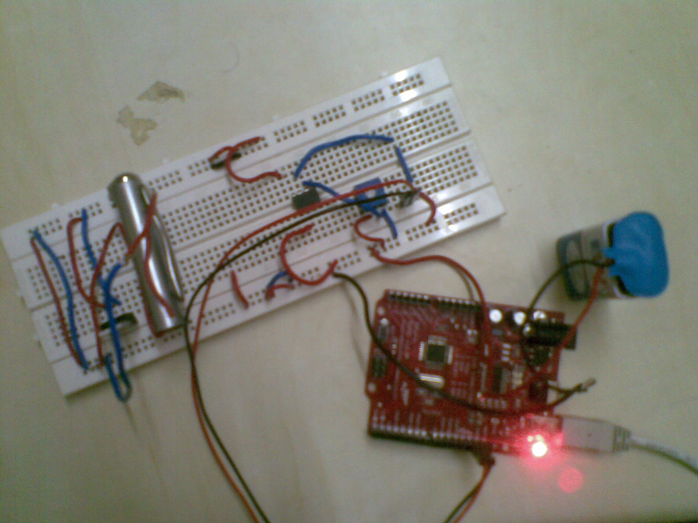

**Outputs of sender**

Preparing to send the character to computer

h

Data is being sent now

0

1

1

0

1

0

0

0

The specified char has been sent

Preparing to send the character to computer

e

Data is being sent now

0

1

1

0

0

1

0

1

The specified char has been sent

Preparing to send the character to computer

l

Data is being sent now

0

1

1

0

1

1

0

0

The specified char has been sent

Preparing to send the character to computer

l

Data is being sent now

0

1

1

0

1

1

0

0

The specified char has been sent

Preparing to send the character to computer

o

Data is being sent now

0

1

1

0

1

1

1

1

The specified char has been sent

Preparing to send the character to computer

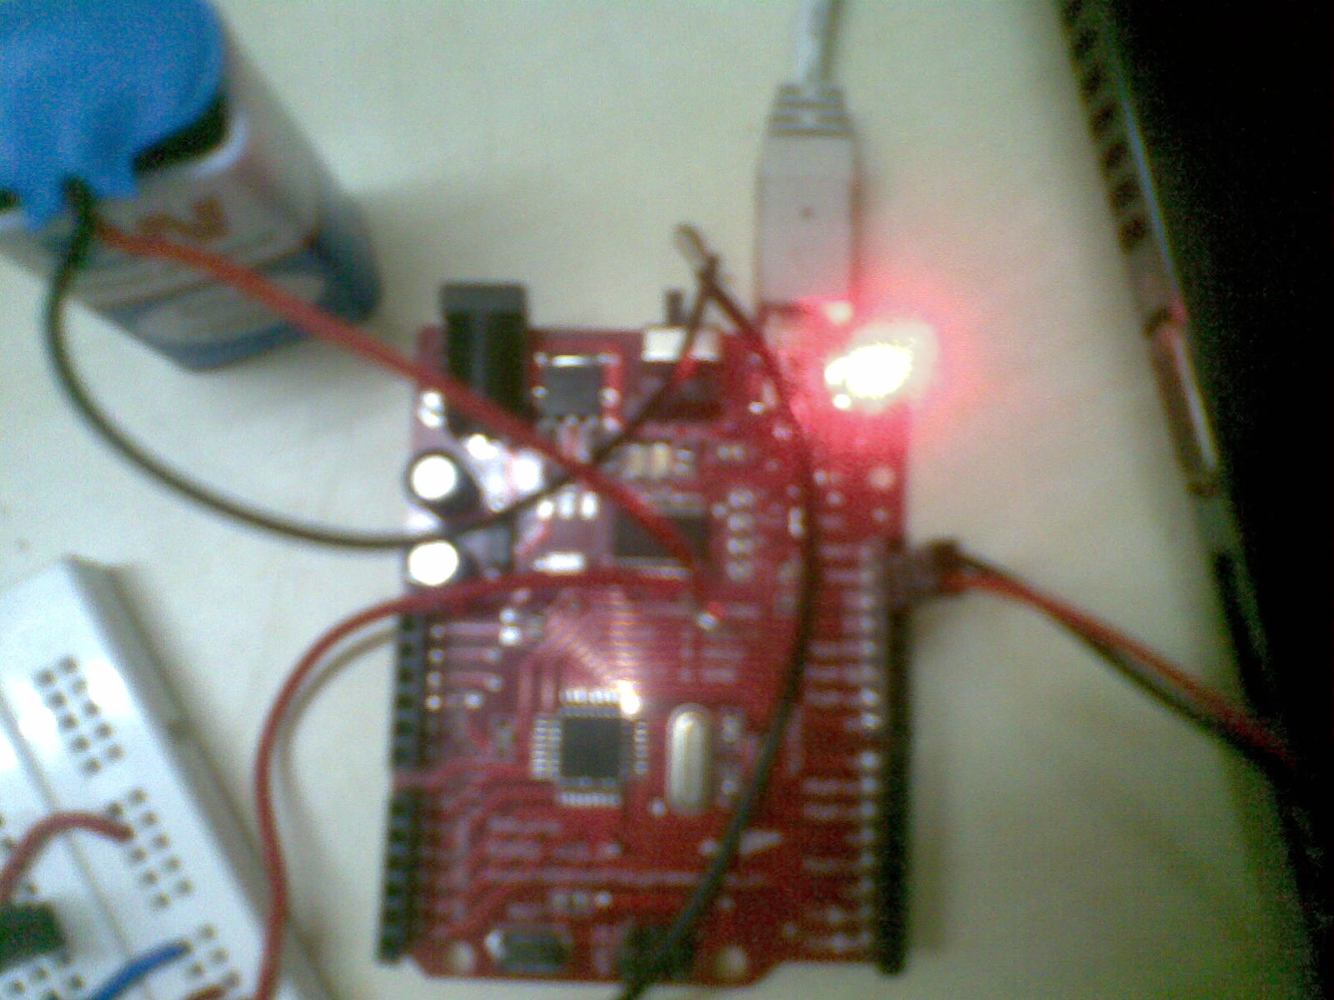

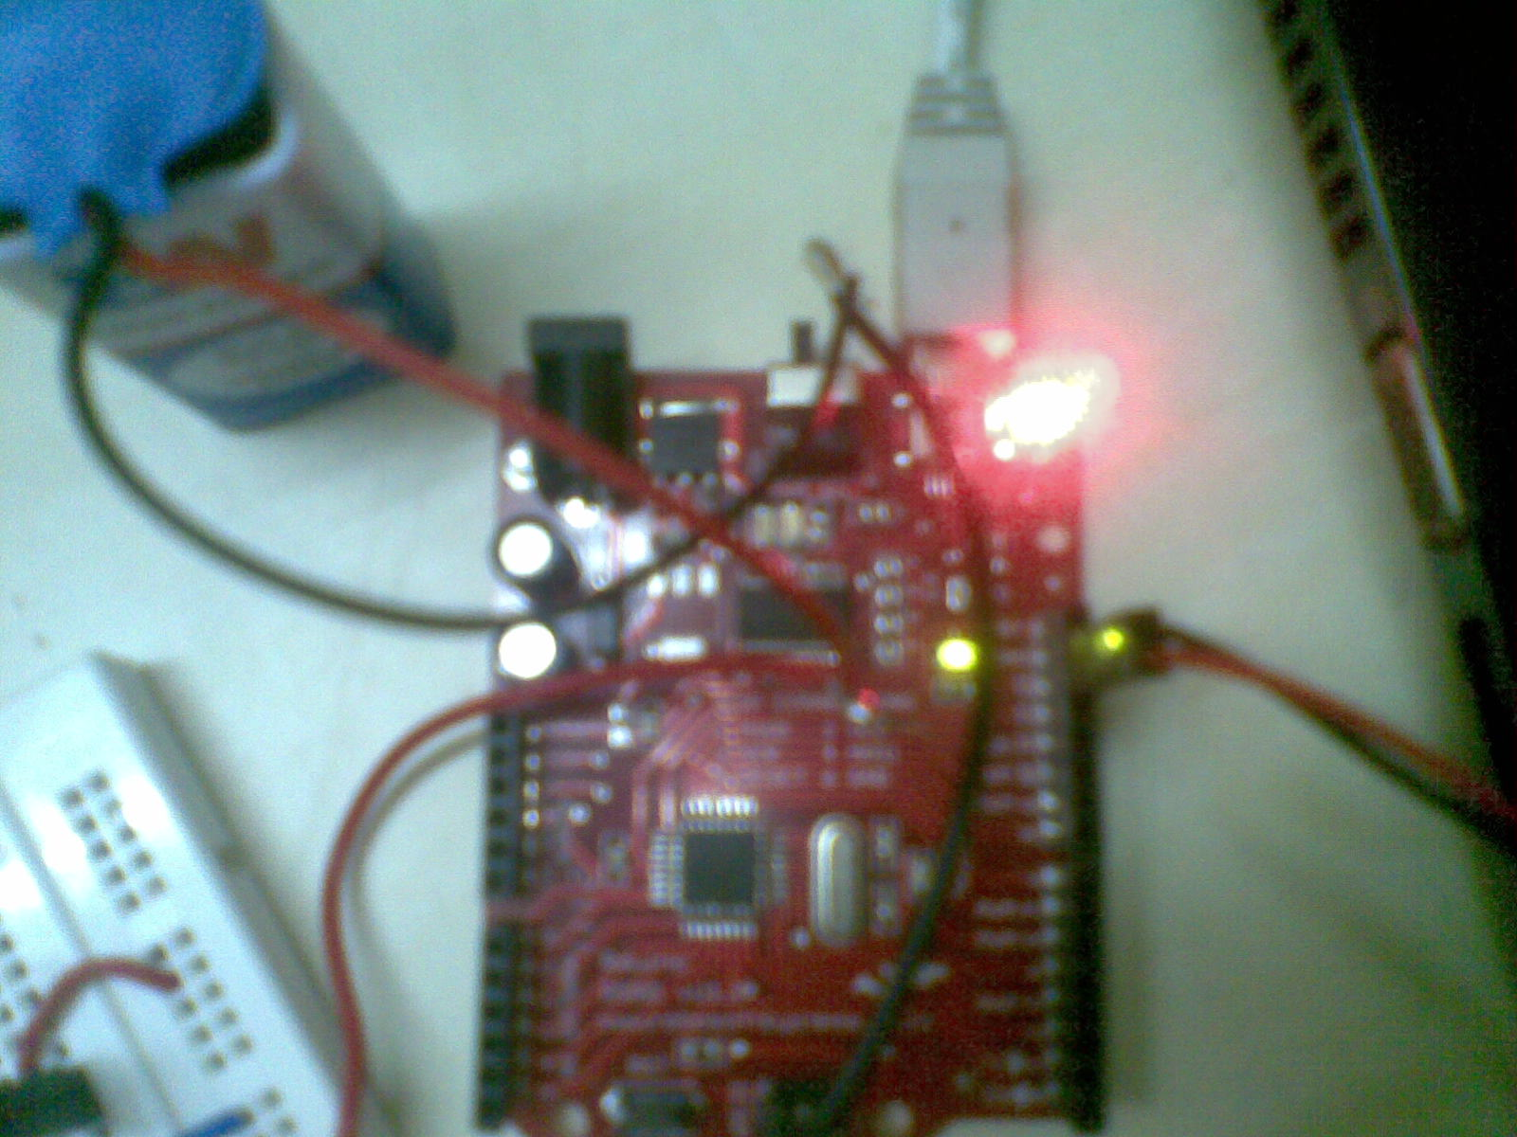

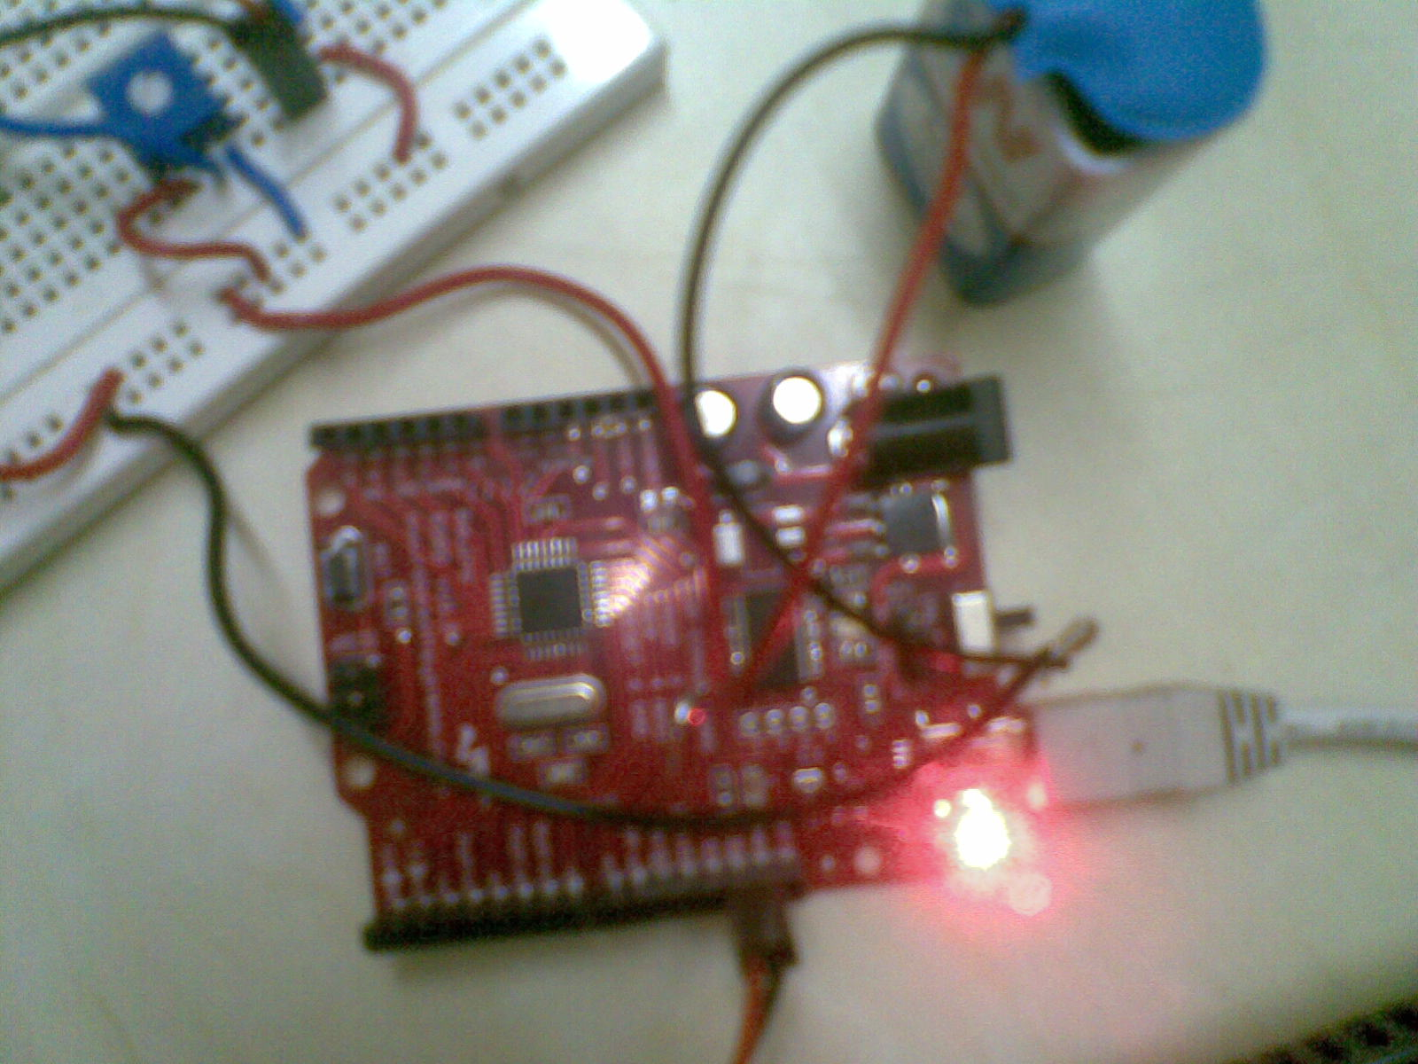

Receiver circuit and Code

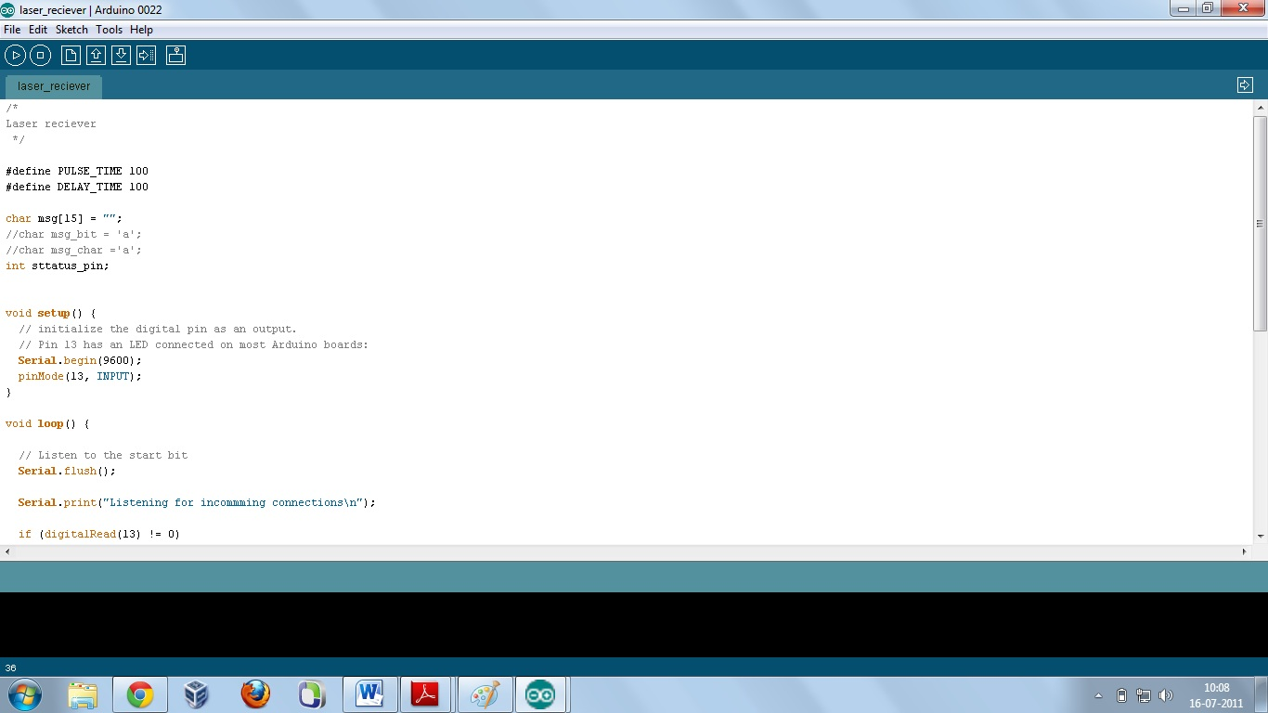

/*

Laser reciever

*/

#define PULSE_TIME 100

#define DELAY_TIME 100

char msg[15] = "";

char msg_char ='a';

int status_pin;

int n=5; // msg size

void setup() {

// initialize the digital pin as an output.

// Pin 13 has an LED connected on most Arduino boards:

Serial.begin(9600);

pinMode(13, INPUT);

}

void loop() {

// Listen to the start bit

Serial.flush();

Serial.print("Listening for incoming connections\n");

if (digitalRead(13) != 0)

{

Serial.print("Request for connection is recieved and reciever is in listening mode\n");

delay(40);

/ /Sense the data 8 times..

for (int i=7;i>=0;i--)

{

delay(98); // 98 to compensate the extra programming delay time wasted

status_pin = digitalRead(13);

Serial.println(status_pin,DEC);

if(status_pin)

{

// set the corresponding pin

msg_char |= 1<<n;

}

else

{

//clear the bit

msg_char &= ~(1<<n);

}

}

Serial.print(msg_char);

Serial.print(" is recieved");

Serial.print("\n\n");

msg[n] = msg_char;

n--;

}

Serial.print(msg);

Serial.print(" has been recieved successfully");

}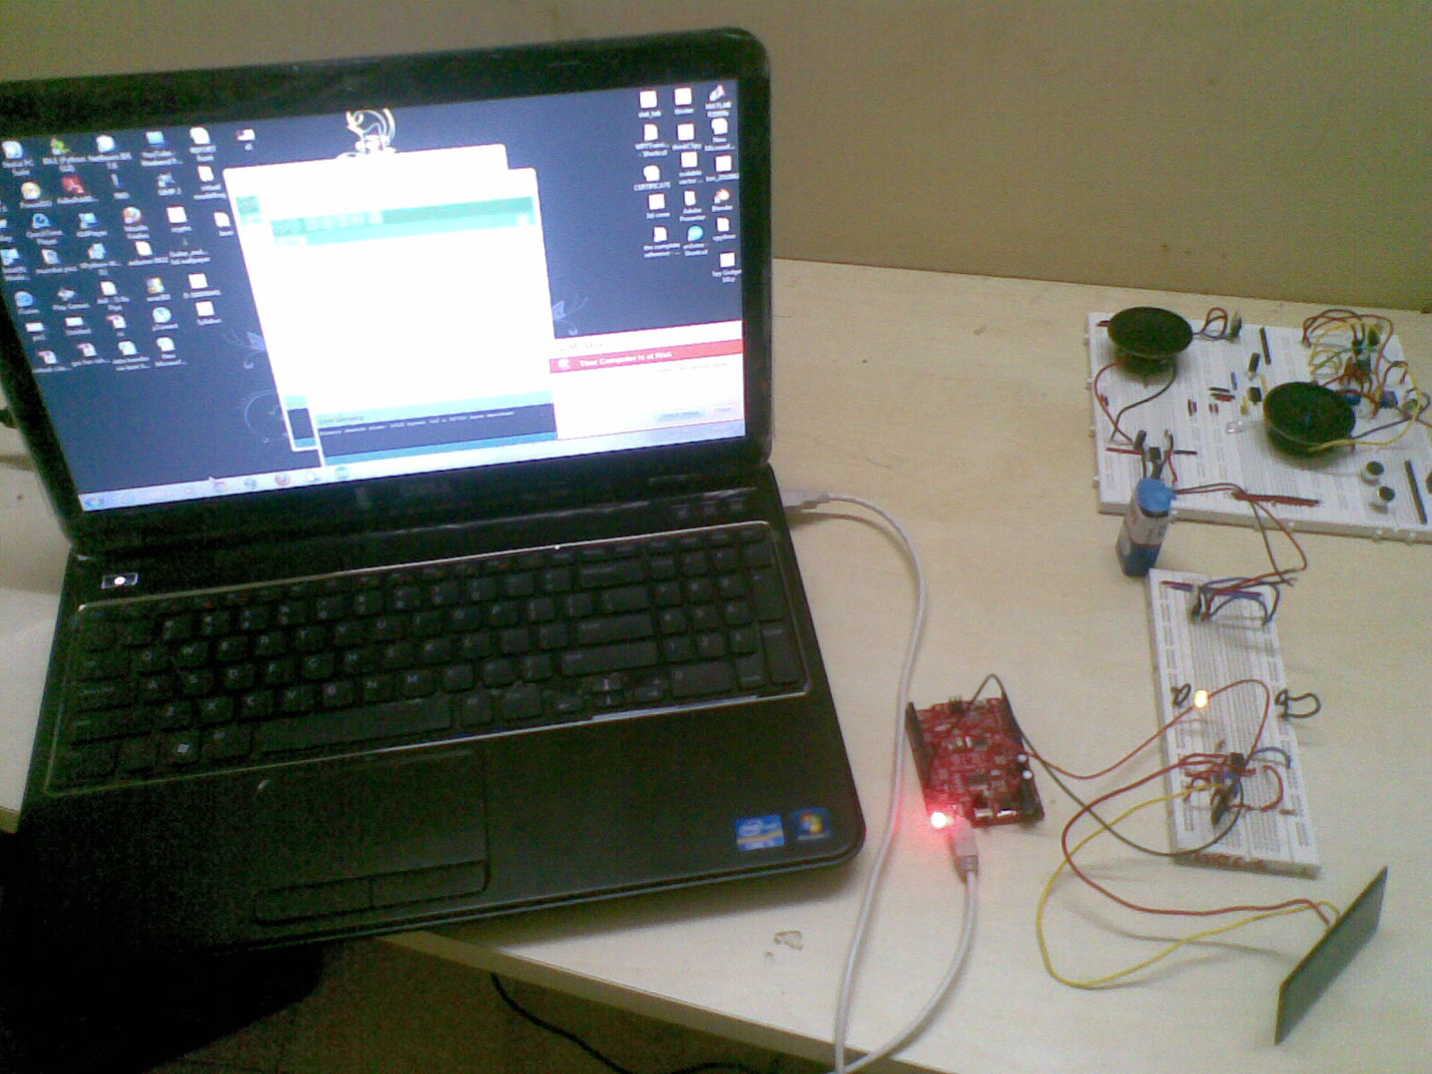

**Outputs of Receiver**

Listening for incoming connections

Receiving the character

h

Data is being received now

0

1

1

0

1

0

0

0

The specified char has been received

Receiving the character

e

Data is being received now

0

1

1

0

0

1

0

1

The specified char has been received

Receiving the character

l

Data is being received now

0

1

1

0

1

1

0

0

The specified char has been received

Receiving the character

l

Data is being received now

0

1

1

0

1

1

0

0

The specified char has been received

Receiving the character

o

Data is being received now

0

1

1

0

1

1

1

1

The specified char has been received

DEVELOPMENT OF DATA TRANSMISSION SYSTEM

For transmitting information to receiver unit, two data sources are under studied. Both sources output the data frame of 8 data bits, no parity and 1 stop bit to the same optical driver unit. Then that serial data from any host is converted to light signals by optical transmitter unit. But, obviously seen, any keystrokes and files can be transmitted in binary form in “PC as a host” system while keystrokes in “PIC as a host”. If one needs to share all files stored in PC to his client, “PC as a host” can fulfill his wish. However, for chatting with other, he can do it by “PIC as a host” by typing and letting him know his words. Then, needing only keyboard and just compact circuitry, one can send information easily to remote site by that. So, chatting is convenient by “PIC as a host” and sharing by “PC as a host”.

**PC as a Host**

In “PC as a host” system, RS-232 serial port of PC is used to output asynchronous serial data to optical transmitter part. The software program is written to convert the ASCII characters to RS-232 data frame and that data passes through the transmit pin of a male connector on the back of the host PC. The serial cable is needed for sending that data to the inserted DB 9 female connector on data transmitter circuitry. Since the transmit pin (pin 3) of the female connector is connected with MAX 232 IC chip, as soon as that connector accepts the serial data from host PC via its receive pin (pin 2), this level converter translates that signal into 5V TTL logic. That is, the receive pin (pin 13) gets the ± 12 V serial signal and pin 12 outputs 5V logic according to its internal operation.

For this reason, a specially designed MAX 232 chip is used to interface between 5V logic levels and the ± 12 V of RS-232, it generates the ± 12 V internally using capacitor charge pumps, and includes four inverters, two transmitters and two receivers in the same package.

It is not a simple case of simply sending bytes from one location to another. Software program is needed to put the ASCII characters of typed data or all files those are stored in PC in serial data frame. This is done by simple C program and extended visual basic program for perfect transferring.

**PIC as a Host**

Also in “PIC as a host” system, PS/2 serial port is used for sending keyboard data to PIC and then PIC translates those to serial data to be transmitted by assembly language. Any keystrokes on the keyboard that is interfaced with PIC will send the corresponding scan patterns from the keyboard to that PIC via PS/2 connector inserted on. Afterwards, the microcontroller converts the keyboard scan patterns to ASCII characters and transmits them to the RS-232 target device.

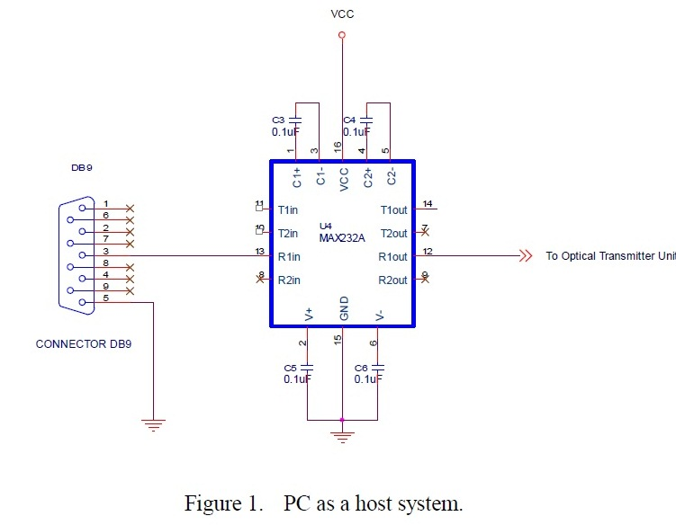

The fact that the scan pattern acquisition is carried out using an interrupt service routine and the decoding thereof is done during normal operation mode allows for performing other tasks concurrently. It does not block the processor while acquiring data.

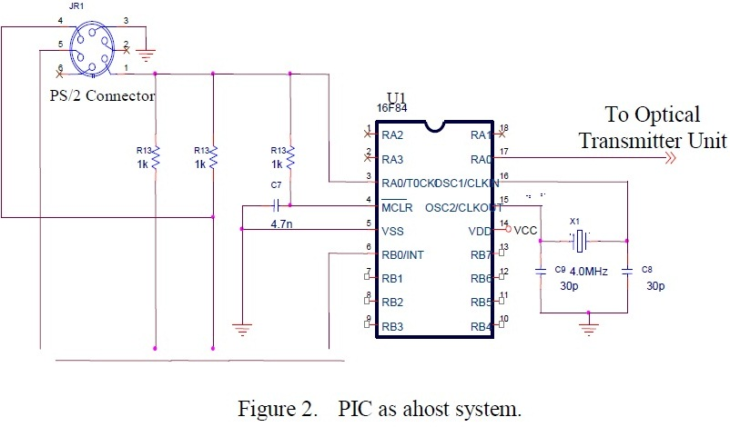

Then the whole keyboard can pattern fetch, decode and RS-232 data transmission is done by software.

Optical Transmission Overview

**Optical Drive Circuitry**

Since both hosts use the same optical transmitter circuitry, information from any host comes as a serial data frame to the optical transmitter unit. As the two inputs of Schmitt inverter is connected together, it acts as an inverter and its output pin is then connected also to two inputs of another gate then the incoming signal is shaped into squarer signal at the final output of Schmitt Buffer. The current source controller is needed for providing enough drive current for the laser diode and also for adjusting the intensity of light output. The intensity of laser diode can be adjusted by variable resistor. The visible red laser module is extracted from laser pointer and it serves as a light source. It itself includes the current limiting resistor. The npn transistor C 945 is required for driving laser diode which operates as in On-Off Keying scheme for representing the incoming signal into equivalently light pulses. Then the light signal is transmitted through open space in wireless laser link and plastic fiber cable in simple fiber link.

Transmission Media for Present Optical Links

Since this project emphasizes optical communication techniques, both cable less (free space optics) and cabled (fiber optical) transmitting systems are tested for sending information from one place to another. Free space optical link is the entry level for fiber optics but the transmitted light pulses are sent to the receiver unit by passing through the open space as a transmission medium. In this fiber link, a single sideband plastic fiber optic cable is used; having optical diameter of 6 mm and the laser module is placed at the end of that fiber. Then, the information from any host will transfer to the receiver site through optical medium.

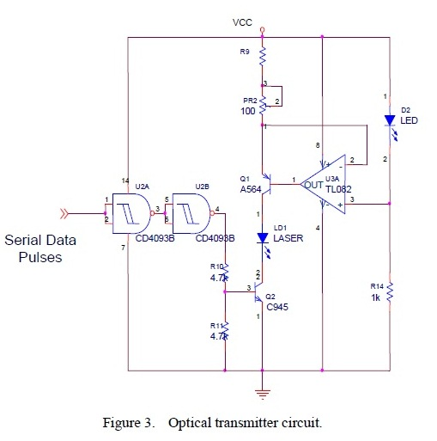

RESULTS AND DISCUSSION

The current optical link under studied offers many advantages and that can operate up to 115Kbps at 30 feet transmitter to receiver spacing. Moreover, not only the keyboard hit characters but also all types of files including images can transfer through.

**Comparative Analysis**

This system involves various aspects in data communication and in optical communication. Among them, the following aspects are in account for comparing their performances.

**Free Space Optical (FSO) vs Plastic Optical Fiber (POF) Links**

According to the theory, a free space laser link has the same speed with the speed of light, also with the fiber link. Via free space laser link, data is transmitted in a similar way to fiber optics, but without the fiber. Though 'optics without the fiber' may have its own problems trying to get off the ground, since obviously the light needs a line of sight to work and the light can be easily blocked by opaque materials. Then, ambient light effects and object disturbances are the major obstacles of cable free communication.

But interestingly, blocking the light is being spun as a security feature, where unwanted eavesdropping can be prevented by simply containing the light, but it's probably more of a drawback since it fundamentally limits the practical distances the light can travel reliably.

Moreover, both transceivers need stable mounting and careful alignment.

Plastic fiber optics can be the solution to these problems. It is a newer plastic-based cable which promises performance similar to glass cable on very short runs, but at a lower cost. A large core size and a higher NA have several advantages. Light is launched into a plastic fiber with more ease. The higher NA and the larger core size make it easier to make fiber connections. During fiber splicing, core-to-core alignment becomes less critical.

Those fibers also have some disadvantages. As the number of modes increases, the effect of modal dispersion increases. Modal dispersion means that modes arrive at the fiber end at slightly different times. This time difference causes the light pulse to spread. Thus it is true that plastic fiber optic communications is not the ultimate answer to all data communication problems, but it does have definite advantages.

**“PC as a host” vs. “PIC as a host” Systems**

In “PC as a host” system, the success of software implementation are file sharing, key pressing and image transferring with the development of a GUI (Graphic User Interface) by visual basic programming. All data stored in host PC and in all drives can be shared to its client by that software development as demonstrated in above section. Moreover, any key pressed characters were displayed on both monitors of two PCs.

In contrast, “PIC as a host” system is also designed for saving power consumption, money and taking area. By that system, it is no need to get one set of computer; it only needs a keyboard interfaced to a small PIC control circuitry. Having those two things in hand, one can communicate with the other at remote location by typing that keyboard and letting know his client as his wish.

CONCLUSIONS WITH PERSPECTIVES

As a result, RS-232 and PS/2 serial port interfaced wireless data link and plastic fiber link have been successfully built for building-to-building connectivity and field applications. This laser transceiver is designed to interface to network, providing data rates of 115Kbps at distances of up to 30 feet.

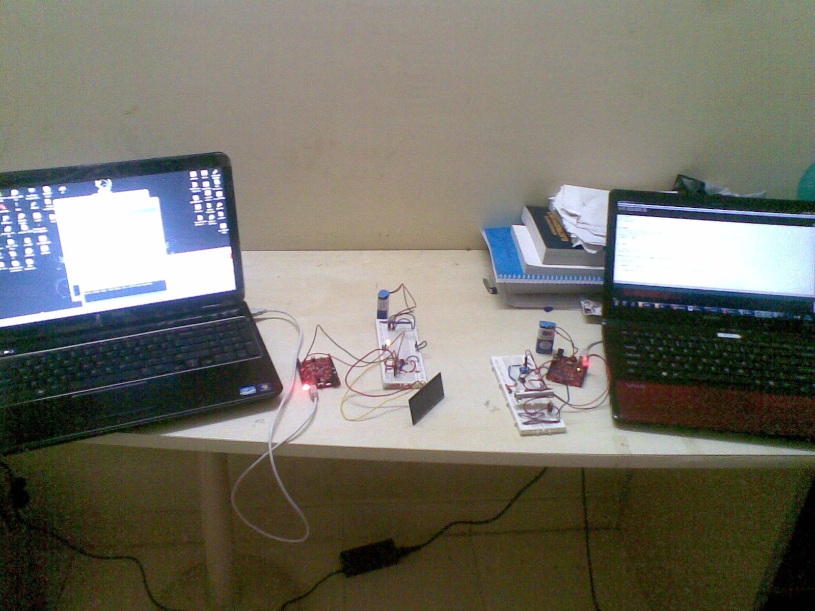

**Circuit Sensitivity**

To know the sensitivity of the hardware circuitry, it had been tested with external oscillator inputting firstly without PC interfacing. Then different frequencies were transmitted through that circuitry and both the input and output were measured by oscilloscope. It was found that the delay occurring at higher frequencies. But it was negligible amount. Both signals were nearly the same except of delay. Since only 300K oscillator circuitry was used, above that could not be investigated. It would be enough for this serial port interfacing. The reasons why this circuit did not go must be in both sites. One of the reasons may be because of the capacitance effect in the system.

Since most laser modules have capacitors to filter power supply noise and switch glitches. These capacitors must limit the switching speed of the laser module but these capacitors are necessary to preserve the laser diode which can be easily damaged. It must be also overcome by using laser diode instead of laser module to get greater optical output power. If greater than 5mW output power laser diode could be afforded to use, it will be more reliable. The ambient light effect can destroy the data frame. It can cause wrong translation at the receiver site. Although in plastic optical fiber link, there might have an injection loss at laser source to fiber core interface, it could not be overcome well.

Moreover, it had been tested that the circuitry in operation is injected by torch light to investigate how ambient light can effect. If this light injects perpendicular to the transmission channel, there is no change in capturing information at the receiver site. But directly injects to the light sensor in the receiving circuitry, it could not detect any incoming signal. It had been totally disturbed. To prove this optical link could not be affected by electrical noises, the whole system had been tested with blender. Then it was found that this system can operate well even the blender produced electrical noises very nearly.

**System Alignment**

The movement of buildings can upset receiver and transmitter alignment. Pointing stability in commercial laser communications systems is achieved by one of two methods. The simpler, less costly method is to widen the beam divergence so that if either ends of the link moves the receiver will still be within the beam. The second method is to employ a beam tracking system. When combined with tracking, multiple beam FSO-based systems provide even greater performance and enhanced installation simplicity.

While more costly, such systems allow for a tighter beam to be transmitted allowing for higher security and longer distance transmissions.

**Summary**

Since the state-of-the art laser technology seems very attracting, laser-based data transmission system was designed and implemented for my research work. Moreover, two data sources were investigated for different data hosts study. Then different interfacing styles of serial port communication were also studied. The interesting keyboard scanning and today up-to-date application of PIC microcontroller firmware involve for this project. For communicating two units: transmitter and receiver, not only hyper terminal serial software was used but also self-developed C program and the graphic user interface of visual basic program for sending characters, all files and images.